Enoch Masih

Continue Setup

10/10/20

**Checking Repository on your system.**

To check the repositories that are present on your system you an used the command sudo dnf repolist. dnf is the replacement for what used to be yum command. Please look at the reference below for the command which was performed on a CentOS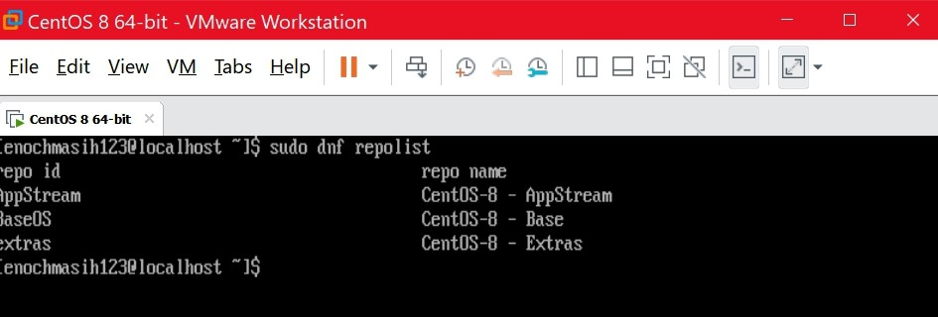

This command may not work on Debian based systems. One can find the repository list by filtering the list with grep command as shown below

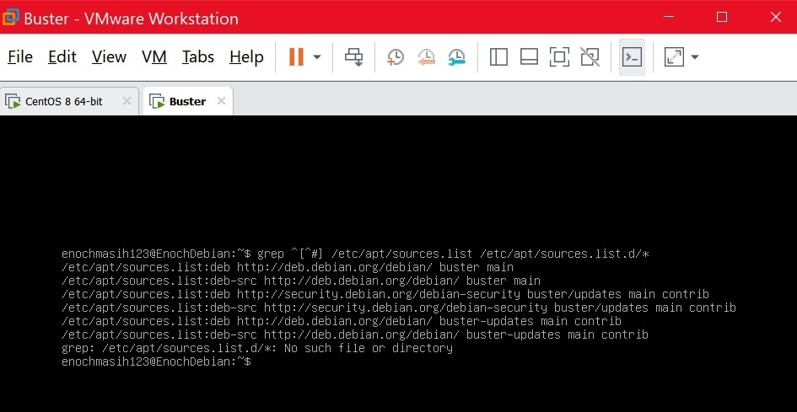

**Adding a Repository to your system**

On a Debian you can add a repository with the following command: add-apt-repository. This command is used to add PPA repositories. On some Debian systems this command may not be present. 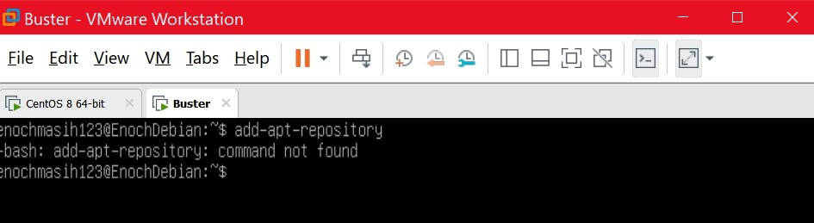 To get this utility in your system, use the command sudo apt-get install software-properties-common. 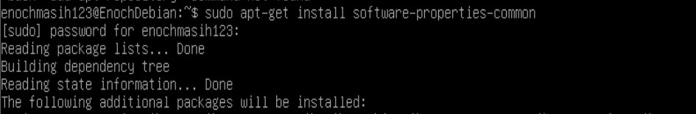

once installed you can man the command to read the manual about the command as shown below. This verifies that you now have the command as part of your system and it’s ready to use to add repositories. 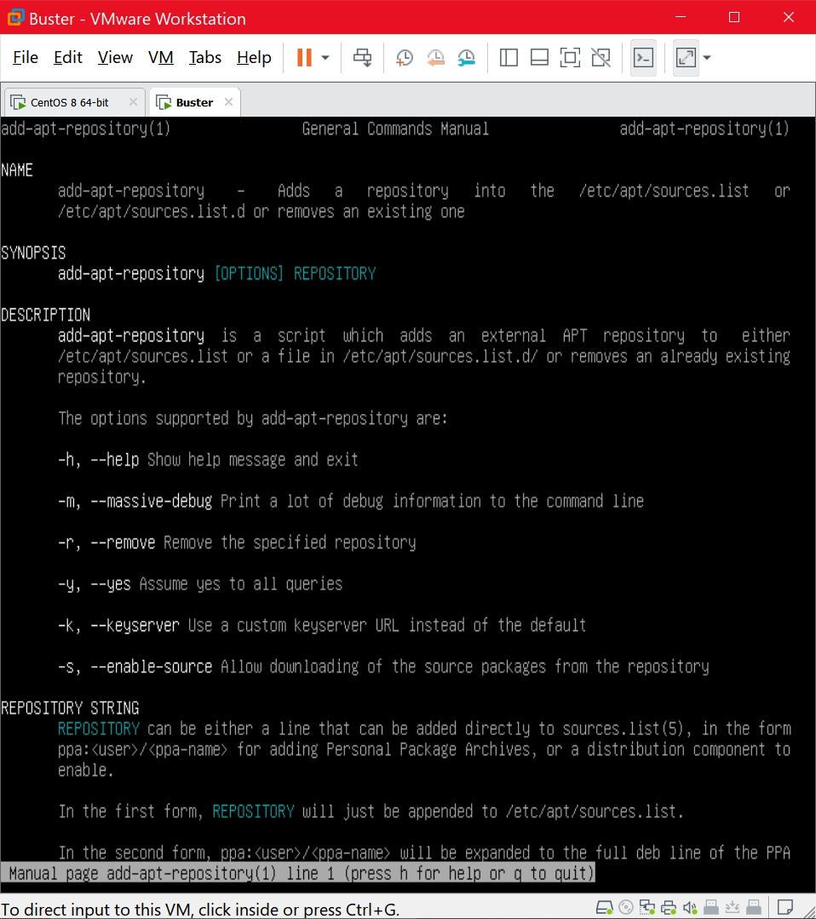

on CentOS you can use the yum install command followed by the path to the .rpm. This path can be a network address. Make sure that you have the Yum library installed (should come with base install of CentOS).

**Update your system**

On CentOS this is fairly easy to do with the command yum update. make sure you run this command using the Super user. This may take some time depending on how much information needs to be updated. Once completed you will see the screenshot below. 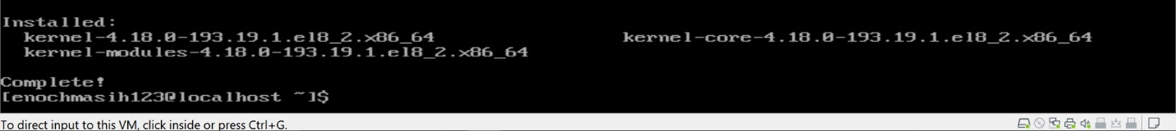 On a Debian use the command sudo apt-get update && apt-get upgrade && apt-get dist-upgrade. This will not only update your computer but also the distribution. 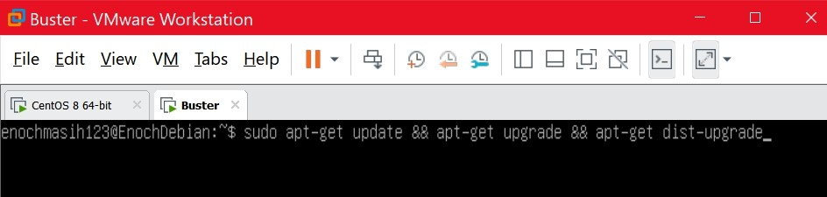

**Installing Tmux**

on CentOS this process can be accomplished by entering the command sudo yum install tmux. Before running the command make sure that your system is up to date as shown above. Below is the install detail along with the date. 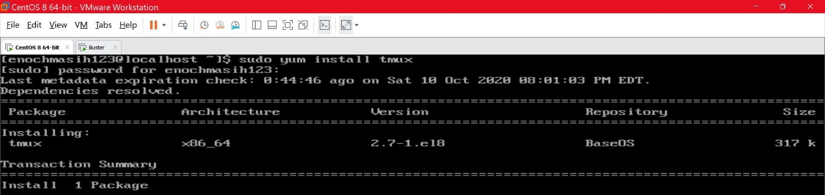 On Debian use the command sudo apt-get install tmux. 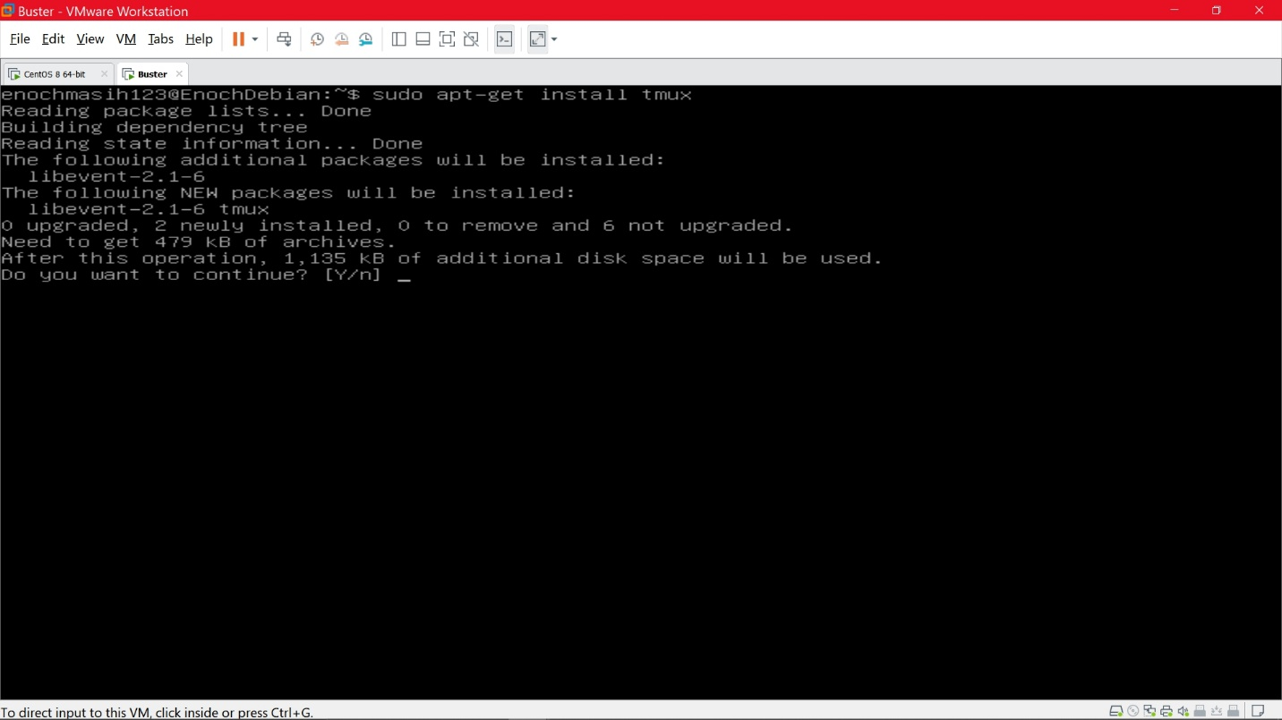

**Installing Emacs**

On CentOS installing emacs is similar to installing tmux. Run the following command as shown in the screenshot below with the date. 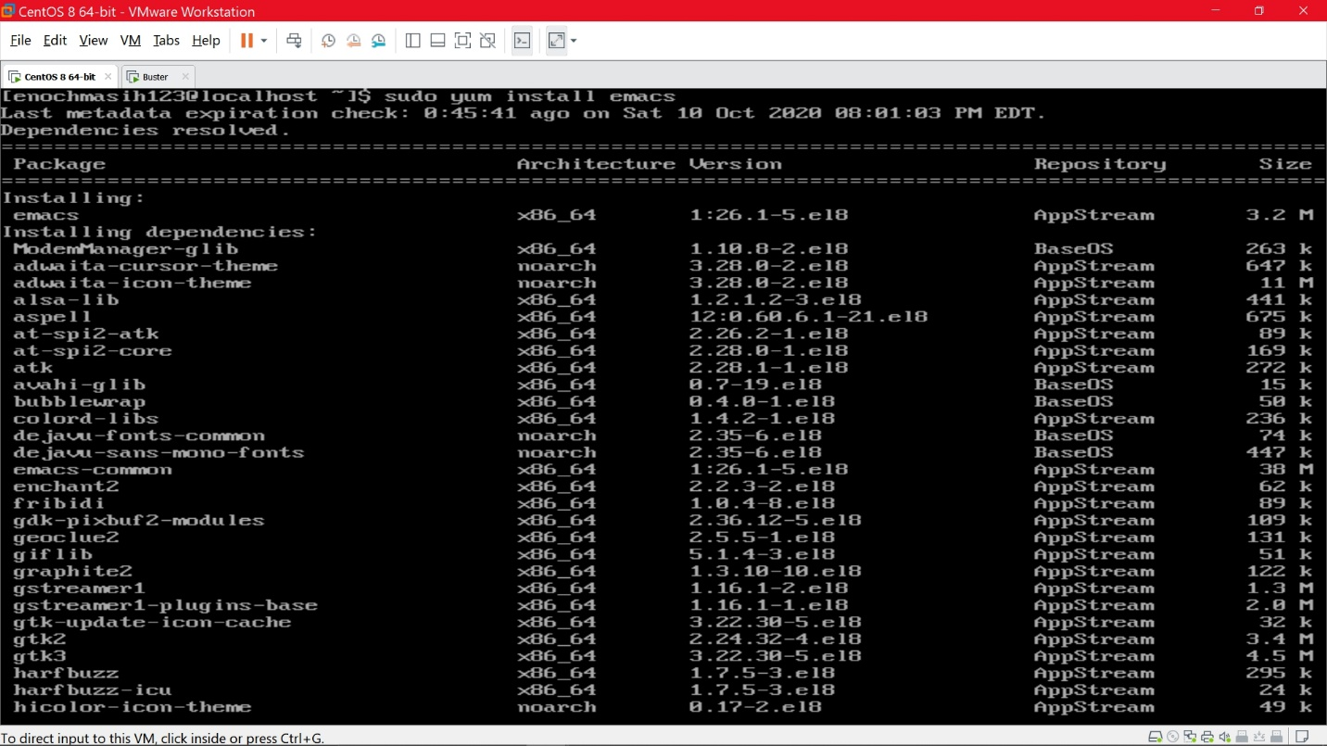

On a Debian you would use sudo apt-get install emacs as shown below in the screenshot. 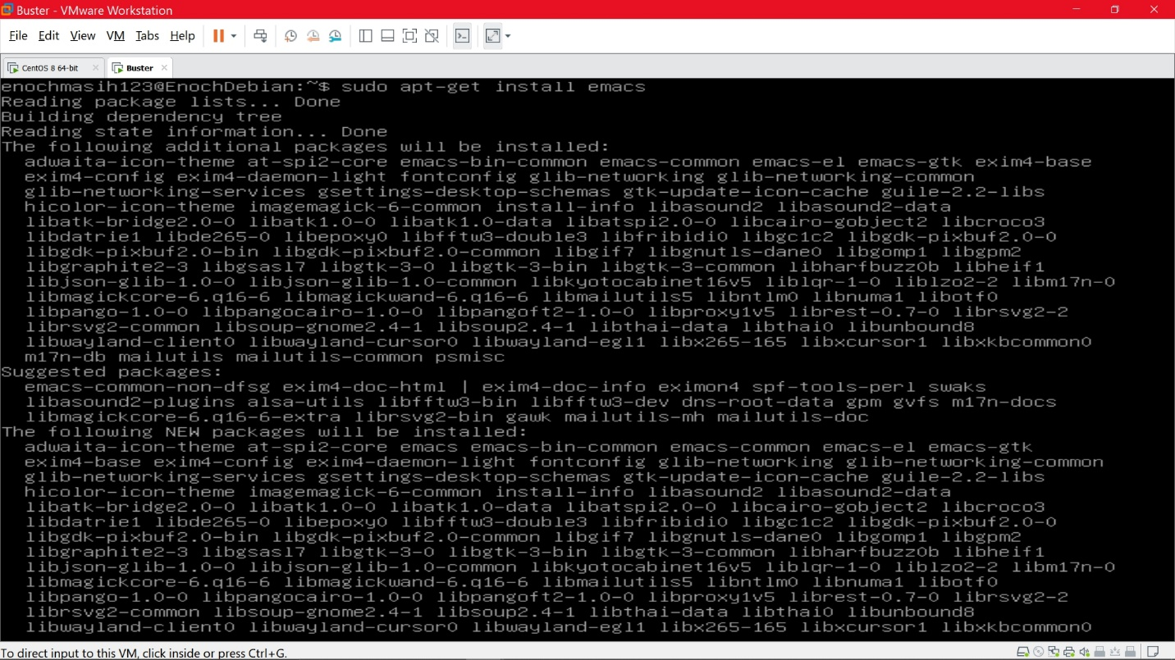

**Installing Fail2Ban**

On CentOS this process isn’t as straight forward as the others. You would have to install some packages before installing Fail2Ban. Please make sure to install this first sudo yum install epel-release first. and then install fail2ban as shown below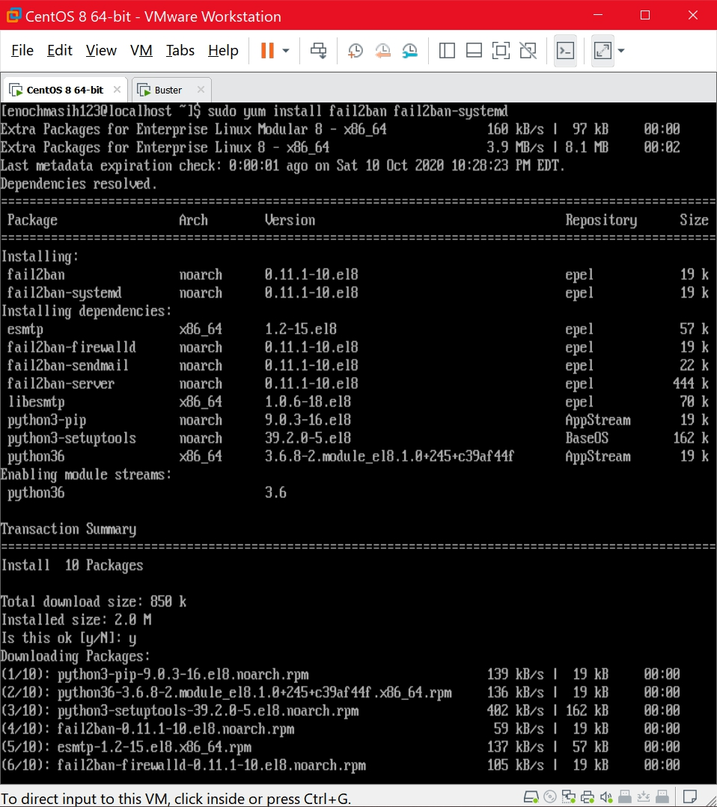

Once installed you can configure the system. Make a copy of the jail configurations and save it with the name jail.local. Jail is really just rules that the application can set. Open jail.local with a text editor and verify. To protect the SSH connection create a new file nano /etc/fail2ban/jail.d/sshd.Local and add the following code: 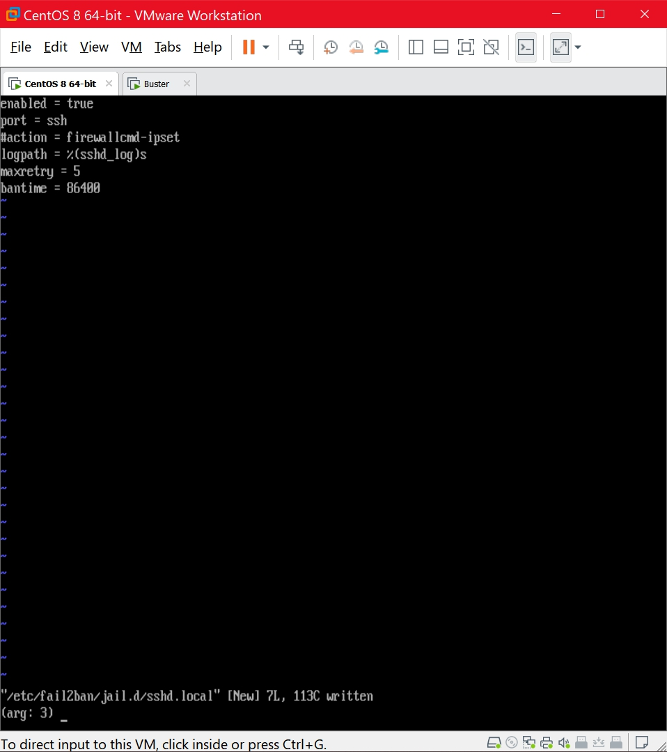 (note that I used VI with a sudo command to edit the text). Now you are ready to use protective Fail2Ban services. Use the command systemctl enable fail2ban, systemctl start fail2ban.

On a Debian before you install Fail2Ban make sure you have aptitude. I did not have it on my Debian system so I had to download it. see screenshot below for details. 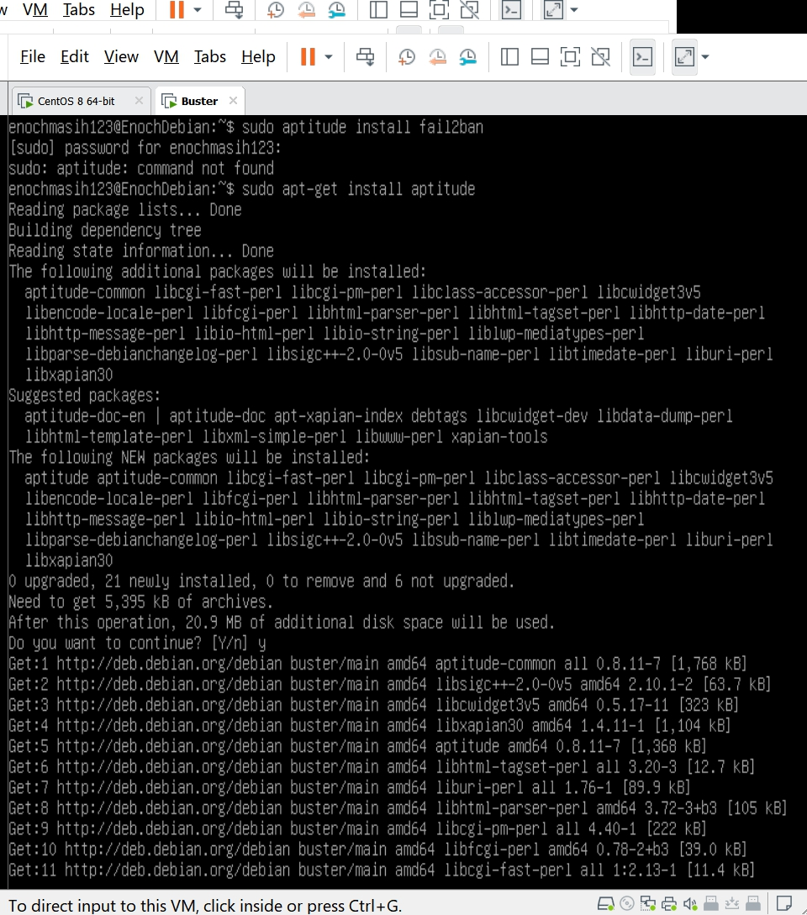 Once installed you can begin to install fail2ban with aptitude as shown in the below screenshot. 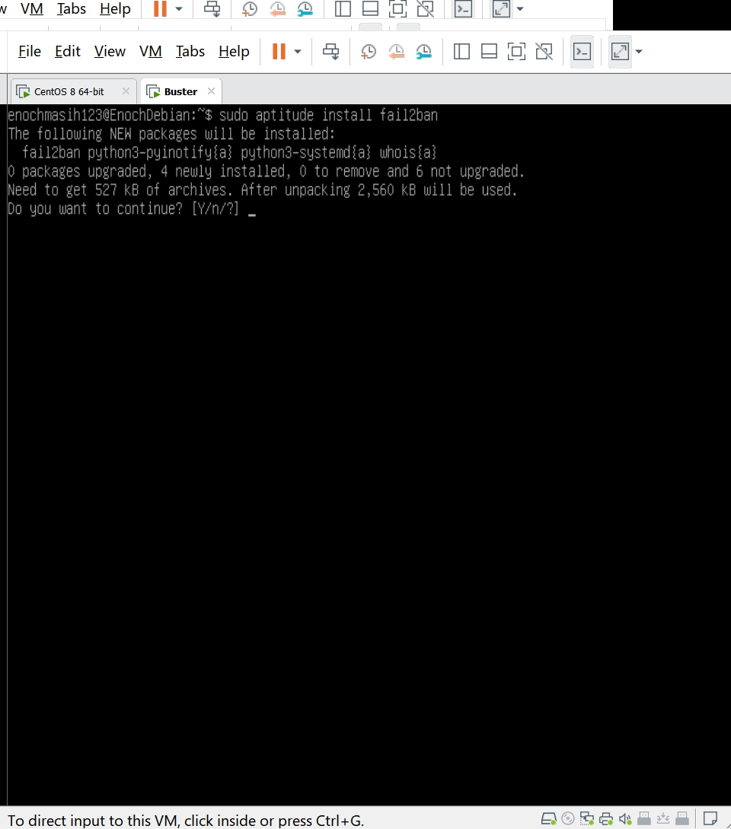 Once installed, we will perform the same process as we did for CentOS and configure the application. first we copy the file to a jail.local (screenshot below) You can search this directory and enable a rule (jail) by the command enable jail for example as we did with ssh in CentOS. Once you enable an option make sure to restart the service as shown below for it to take effect.

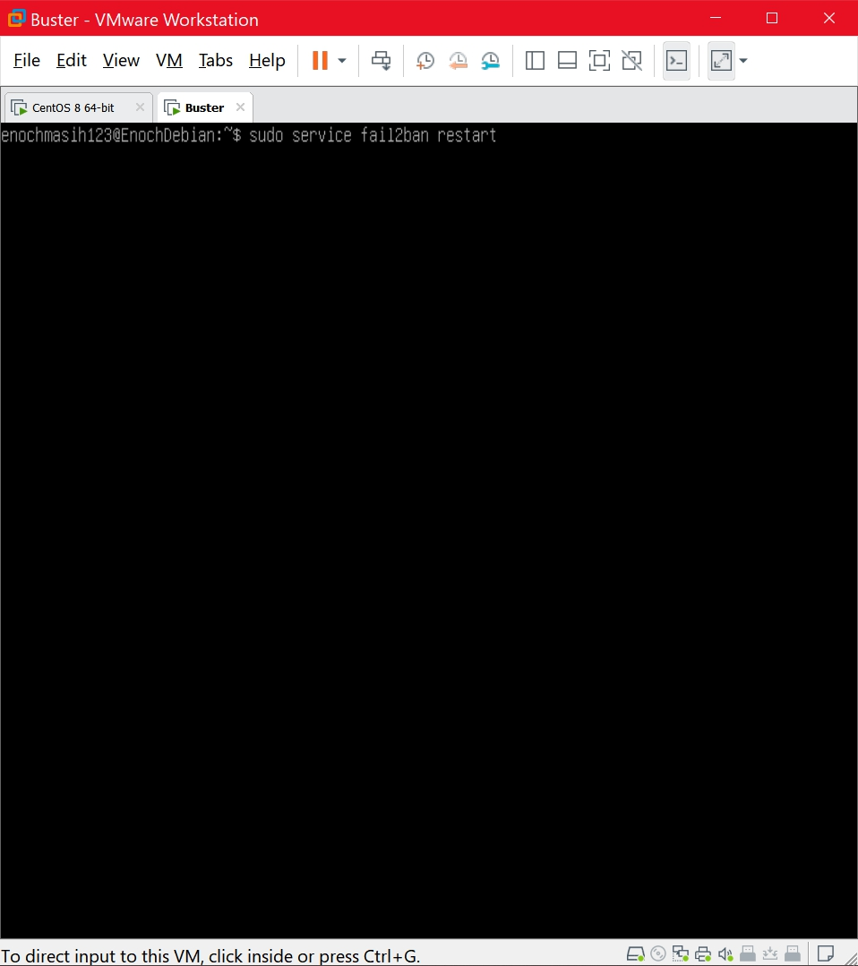

**Update vim**

on centOS: 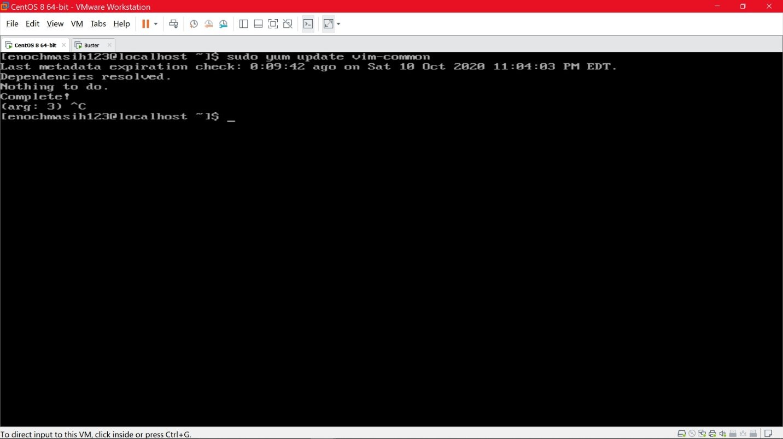

on Debian: See screenshot below. when installing it, it contacts the appropriate repository and installs the newest version of the application. Note that vim has a lot of modifiers that can be installed. 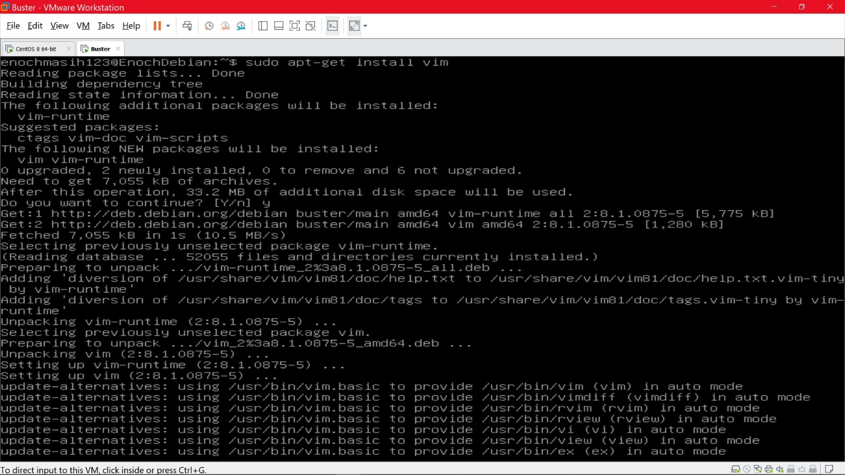

On

cc